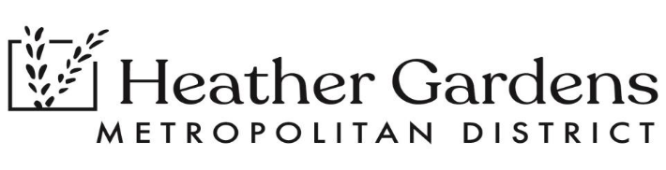
HEATHER GARDENS METROPOLITAN DISTRICT
ANNOUNCES
A Joint Meeting with
Heather Gardens Association (HGA) Board of Directors
and
Heather Gardens Metropolitan District (HGMD) Board of Directors
Pursuant to Section 24-6-402(2)(c), C.R.S., the Heather Gardens Metropolitan District hereby gives notice that it will hold a Joint Session of the HGA Board and the HGMD Board on Thursday, January 11, 2024, at 3:00 p.m. in the Sandberg Auditorium located in the Heather Gardens Clubhouse and via Zoom.
Join Zoom: By copying and pasting the address below into your server:
https://us06web.zoom.us/j/83038167513?pwd=fBvjLXhoFXUB2FiKQk0PtGScw6pWXV.1
Meeting ID: 830 3816 7513
Passcode: 969431
Or Dial-In: +1 346 248 7799
AGENDA
Pledge of Allegiance
HGMD determine quorum and open meeting
HGA determine quorum and open meeting
Facilitator comments
Explanation of each board’s responsibilities within the community:
- District - 3 minutes
- Association - 3 minutes
NEW BUSINESS
- Settle upon next steps for items that are mutually agreed upon
- Management Agreement re-design
- Implementation
- Organizational Chart
- Review and update current Org Chart
- Discuss proposed changes to Org Chart under a new Management Agreement
- Strictly District -Strictly Association -Identify mutual needs
- Contracting Process
- Joint Budget & Finance Committee meetings
- Contract approval process
- Authorization of District Payments
- Invoice approval process
- Check signing authority
- Communications
- Community communications --Staff communication
- Staff attendance at meetings
- Public Comments/Questions
Adjournment
Next Leadership Work Session Thursday, February 8, 2024, at 3:00 p.m.

