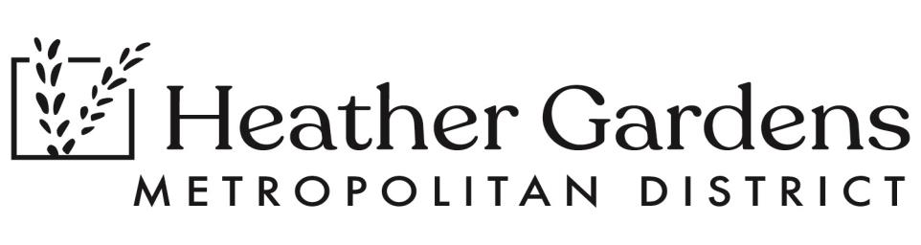

**HGMD RESTAURANT COMMITTEE STUDY SESSION**

**OCTOBER 10, 2024 3:00 - 5:00 PM BANQUET ROOM**

**REPORT**

**PRESENTATION: TEST FIT - Marc Shen, MALIKAI ARCHITECTURAL DESIGN**

Committee Members were presented with the visual Test-Fit for remodeling of the restaurant to better meet the needs of the residents and customers of Rendezvous Bar & Grill.

**The items to address with the test fit are:**

* Handicapped Accessible Doors leading out to the back patio facing the pool area
* A clear entry way into the restaurant - eliminate the “Twilight Zone” entrance
* Expanding the kitchen space
* Increasing seating
* Extend the current roof line to Increase more covered patio seating
* Create a “grab and go” space
* Create a side entry way to the restaurant to draw golfers, tennis players and pickle ball players into the restaurant

**There was much discussion and many questions**

**Phasing in any changes will require a detailed plan and a detailed budget**

**NEW BUSINESS**

**SIGNAGE** - Crystal, Cormac and Greg Kohr will work together to get some temporary signing to identify the parking areas, the restaurant and the pro shop

**PROCEDURE MEMORANDUM:** Gwen and Tom will review, complete and submit to committee for next meeting

**VETERAN’S DAY EVENT UPDATE**

Sunday, November 10th - Sunday Brunch for Veterans will be $8.

Monday, November 11th Celebrating our Veterans Event - Live Music, Punch and Cookies by Cormac

3: 30 - 5:00 in the Auditorium

**PUBLIC COMMENT** on Non-Agenda Items (limit 5 minutes per speaker)

**Questions re the layout of the restaurant and access for all:**

* **Linda Hileman, Director on HGA Board**
* **Connie Burns, HGMD Volunteers Coordinator**

**NEXT MEETING:** **THURSDAY, OCTOBER 24, 2024 3:00 PM Boardroom & Via Zoom**